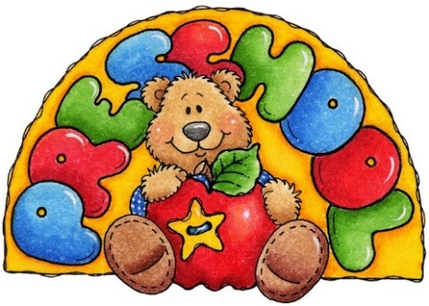
St. Lawrence PreK-4 Student Supply List
2025-2026
- full size backpack (no mini pack) - Label with name please
- 1 complete change of clothes in a Ziplock bag to be kept in backpack at all times (shirt, pants/shorts, socks & underwear)
- 1 Reusable water bottle to bring daily- Label with name please
- (1) 4 pack Play-Doh brand containers (NO 24 mini packs please)
- 1 two pocket folder – Label with name please
- 1 small (5” x 8” standard size) plastic supply box to hold crayons, scissors & glue sticks – Label with name please
- 1 box washable markers
- 3 packages of LARGE glue sticks (disappearing purple glue preferred)
- 1 set of watercolor paints
- 3 packs Crayola brand crayons (jumbo or regular grip)
- 4 dry erase markers (any color)
- 1 pair of child safety scissors
- 1 bottle of hand sanitizer (8 oz. or larger)
- 1 package of baby wipes (last name A-M)
- 1 package of JUMBO cotton balls (last name N-Z)

